WANTED
FOR BEING A
RISK TAKER
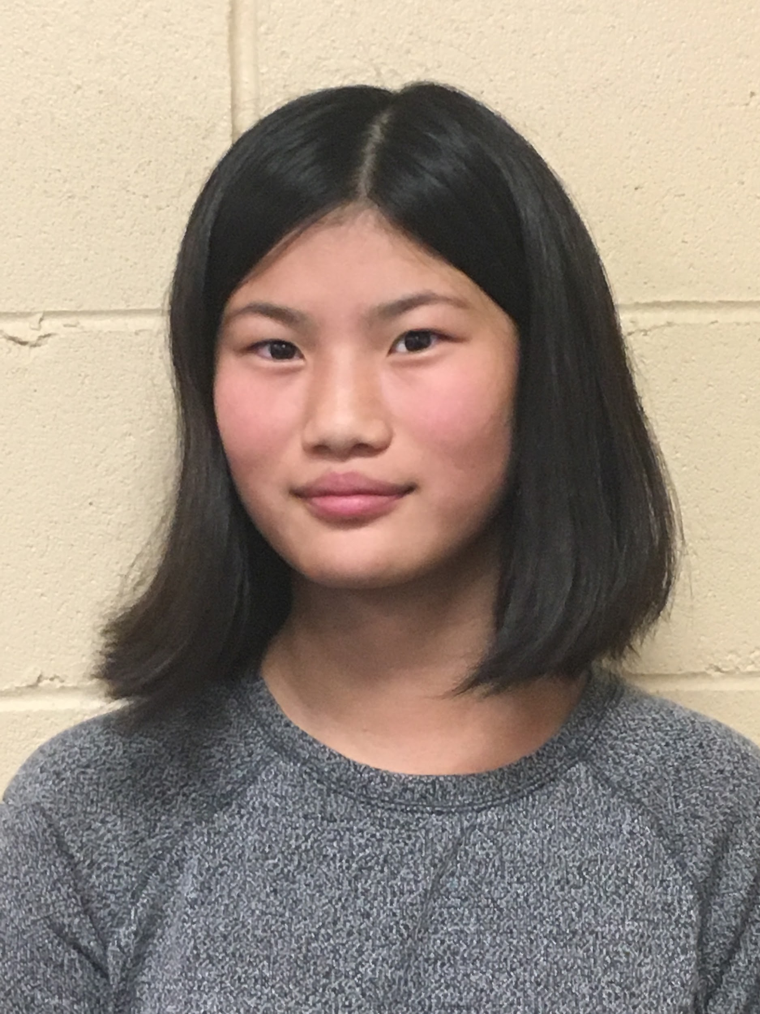
-riding a horse for the first time
-travel to new places
-try new food
-doing different art styles
Reward: $100

